**Red Acre Barn Floor Plan Layout Form**

**Please fill out and bring to the final meeting or email to** [**redacrebarn@gmail.com**](mailto:redacrebarn@gmail.com)**. We will meet at Red Acre Barn 4-6 weeks before your event.**  
  
Name:  
  
Date of Event:   
  
Number of Guests:  
  
Number of Chairs Needed for Head Table:  
  
 **Outdoor Ceremony**Red Acre Barn has 64 benches for the ceremony pad that fit up to 5 people/bench. If you have 300 guests or close to it, I would use all 64 benches.   
  
Example: 8 rows of 4 benches per side of the aisle would be a good set up for 300 guests (64 benches). 8 rows of 3 benches per side of the aisle would be a good set up for 200-225 guests (48 benches).  
  
Number of Benches to Use Overall:   
  
Number of Benches per Side of Aisle:  
  
Number of Rows of Benches:

********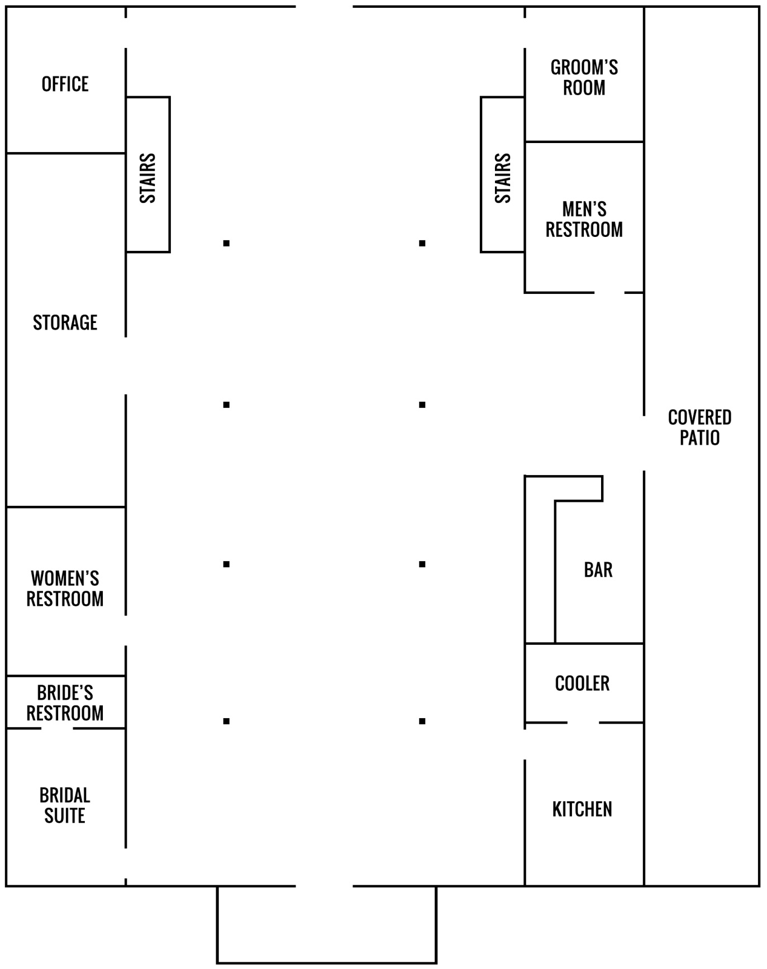**Example of Approximately 158 Guests  
Bottom Floor = 158**Round Tables, 18 Round Tables with 8 People = 144 People  
4 Farm Tables = 14 People

2 Whiskey Barrels  
& Table Top  
Dessert Table

4 Cocktail  
Tables

Whiskey   
Barrel for  
Cake

4 Farm Tables  
Head Kings Table

6 ft. Table  
Non-Alcoholic Drinks

6 ft.   
DJ Table

8 ft. Food Tables

6 ft. Gift Table

6 ft. Guest Table

**  
Loft Floor = 0**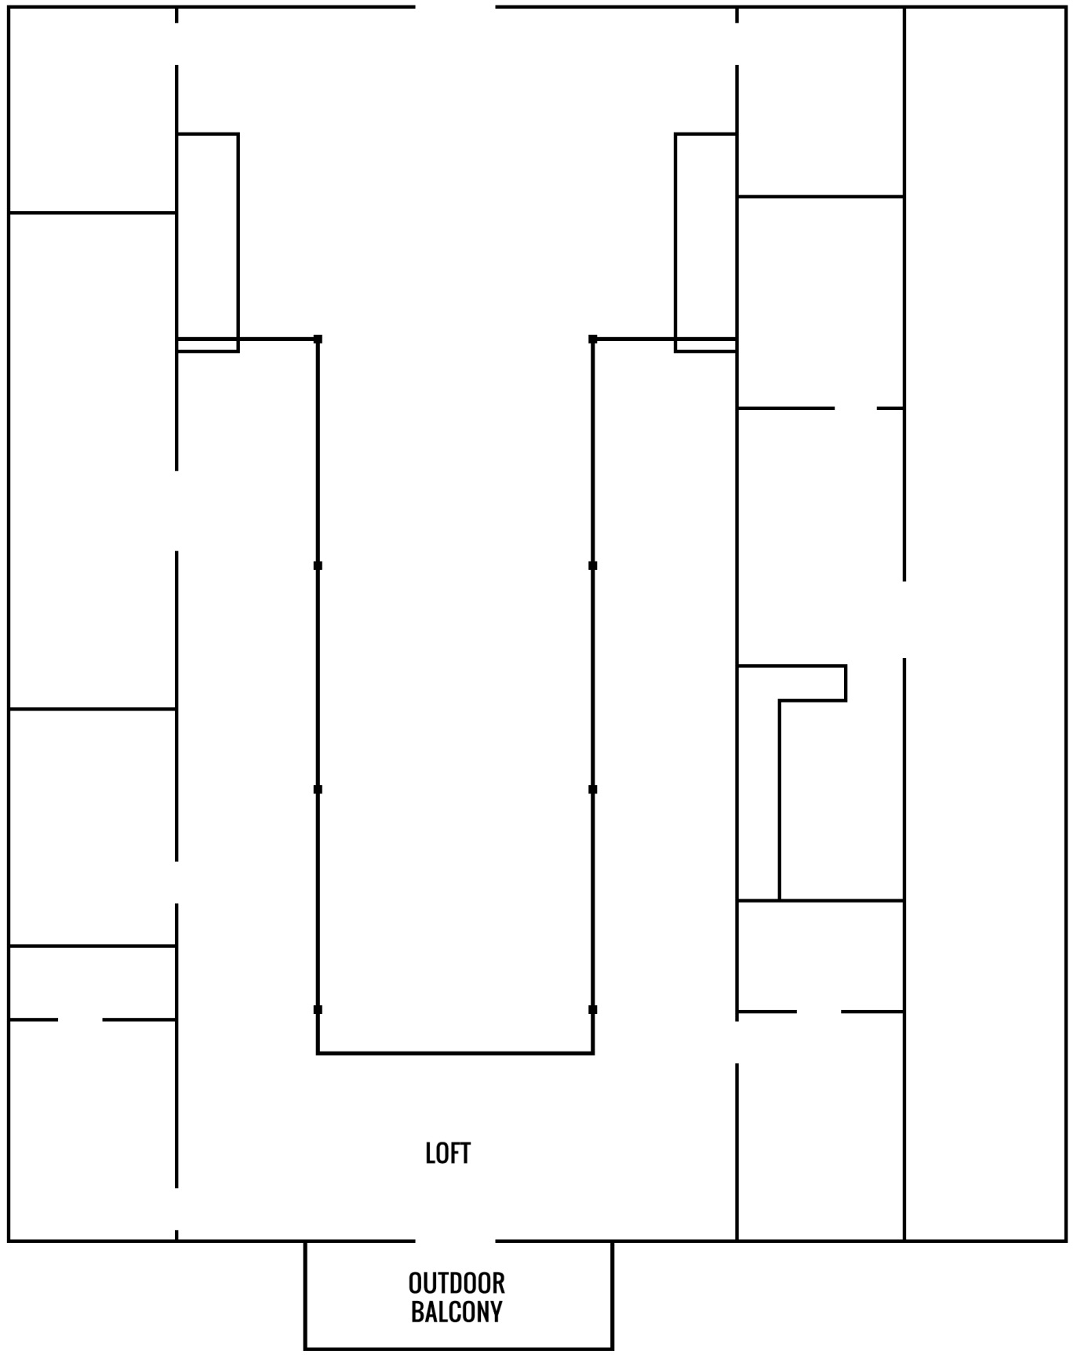

2 Cocktail  
Tables

**Outdoor Ceremony:  
Example of layout for 300 guests**



64 wood benches

Sidewalk

**Indoor Ceremony for 300 People:**- 2 rows of 20 cross back chairs up front for family.  
- Spread tables out wider to make an aisle in the middle. Guests can be seated around the tables.  
- Farm tables used as the head table can be set by the stairs, so they are ready for a quick transition after the ceremony.  
- Loft would be set up the same. **4, Farm Tables**

76"W x 36"D x 30"H  
Seats 6 to 8 people

**27, 6 ft. Rectangular Plastic Folding Tables: Rent 90" x 132" Linens**2 in. thick white granite plastic top

Overall Width: 30 inches

Overall Height: 29-1/2 inches

Overall Depth: 72 inches

**7, 8 ft. Rectangular Plastic Folding Tables: Rent 90" x 156" Linens**2 in. thick white granite plastic top

Overall Width: 30 inches

Overall Height: 29-1/2 inches

Overall Depth: 96 inches

**35, 5 ft. Round Plastic Folding Tables: Rent round 120" Linens**  
2 in. thick white granite plastic top

Overall Width: 60 inches

Overall Height: 29-1/2 inches

Overall Depth: 60 inches

**10, 32 in. Round Cocktail Table: Rent round 132" Linens**  
1.75" thick white granite plastic table top  
Overall Width: 31-1/2 inches  
Overall Height: 43-3/4 inches  
Overall Depth: 31-1/2 inches